World Religions: Buddhism

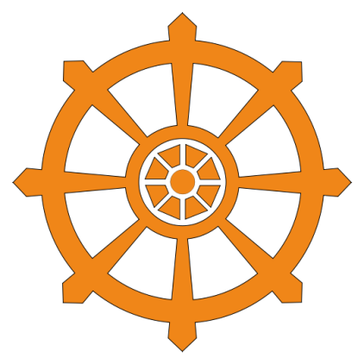
The symbol of Buddhism is a wheel with eight spokes. The middle of the wheel stands for a focused mind, which every good Buddhist tries to achieve by meditating. The eight spokes stand for the Eightfold Path--Buddhism's teachings on how to live your life as a good Buddhist. The edge of the wheel (the "rim"), stands for concentration.

Buddhism began around the year 528 BC. It is believed that this is the year when a young man named Siddhartha Gautama meditated under a tree in his home country of India. While he was meditating, he became enlightened, which means he realized deep truths about life. He realized that suffering was a part of life for everybody, but that it is possible to free yourself from suffering by following certain teachings. He came to be called the "Buddha," which means "Enlightened One." Siddhartha Gautama is considered the founder of Buddhism.

Buddhist people do not worship the Buddha as a god, but they often keep statues of Buddha to help them remember to follow Buddha's teachings. Buddhism is considered polytheistic, meaning that Buddhists can worship many gods. Buddhism doesn't focus on worshipping gods, but it is possible to do so. Most Buddhists live in East Asia.

Most religions have a holy book that teaches about the religion. For Buddhists, that book is called the Tipitaka. Also, most religions have a holy place where they practice their religion. For Buddhists, this place is called a Buddhist Temple.

Buddhists believe that people should stop wanting things and other worldly possessions, so they can reach a state of wisdom called nirvana.

Sources:
http://www.freewebs.com/universal_buddhism/buddhistsymbols.htm
http://www.buddhanet.net/e-learning/5minbud.htm
World Religions: Christianity

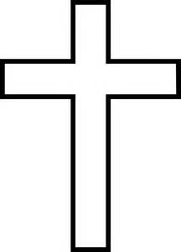
The symbol of Christianity is a cross. Christian people use the cross as their symbol because it is a reminder of their religion's founder, Jesus Christ. He was punished by the Roman Empire because his followers called him a king. This made the Roman leaders feel threatened, so Jesus was crucified, or executed on a cross. That was a normal punishment in his time. Many people were crucified by the Romans.

Christianity probably began around the year AD 33. It is an extension of the teachings of Judaism, which is another monotheistic religion. That means Christianity is monotheistic, too. The big difference between Judaism and Christianity is that Christians believe Jesus Christ is the Messiah, or the Savior (person who comes to save). Christianity is monotheistic, just like Judaism.

The holy book of Christians is called the Bible. Of all the books in the whole world, the Bible is the #1 bestseller. It has sold more copies than any other book. Christianity is found mostly in North and South America, Europe, Africa, and Australia.

There are many words used for teachers of the Christian faith. The word that has been used the most through all of history is "priest." Priests usually work in a holy place called a church, which is where Christians practice their religion.

Christianity is the largest religion in the world, with over 2 billion followers.

Sources:
http://www.christianity.com/
World Religions: Hinduism

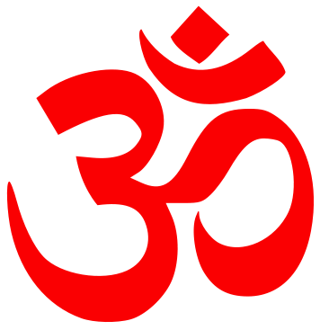
Hinduism is one of the oldest religions in the entire world. It probably somewhere between 2000 BC and 2500 BC. The teachings of Hinduism are always growing and changing, so it is tough to pinpoint an exact date when it began. We do know that it started with the Aryan people of India. It is the world's third-largest religion, but over 90% of Hindus live in India.

Hinduism is a polytheistic religion. Hindu people do not usually try to worship every single god or goddess in Hinduism. Instead, they usually pick one, two, or three gods or goddesses that are meaningful to them. The three main gods of Hinduism are Brahma, Shiva, and Vishnu.

The holy books of Hinduism are called the Vedas. They tell stories about the gods and goddesses. The Vedas are most commonly sung at weddings.

A teacher of the Hindu faith is called a "Guru." In the English language, we have started calling people a guru if they are an expert in a certain subject. Ms. Cruz might be called a softball guru.

Hindu people can practice their religion in a Hindu Temple. There are different temples for different gods and goddesses. Hindu people don't need to gather at a temple each week. Instead, they can stop by the temple whenever they want, so they can offer flowers, food, and money by placing them in front of a statue of a god or goddess. Then they pray. A Guru might be there to help them if they need help. It is very common for Hindu people to pray at home, and they keep statues and prayer corners there, often with flowers, money, and other offerings.

Hindu people believe in reincarnation, which is the idea of living many different lives. They believe that a person will continue being re-born until they have become perfect.

Sources: http://www.hindudevotionalblog.com/2012/11/hindu-om-symbol-pictures.html, http://hinduismfacts.org/
World Religions: Islam

Islam is the world's second-largest religion. It is found mostly in the Middle East, including countries like Saudi Arabia, Syria, Jordan, Iraq, and Iran.

Islam was founded by a man named Muhammad around the year AD 622. He lived in the country now called Saudi Arabia, which is mostly desert. Take a look at the symbol of Islam: the crescent moon and a star. It makes sense that the symbol of Islam would be things that are important to people in the desert. The moon and stars were important for telling directions during the cool desert night.

People who follow Islam are called Muslims. Islam is monotheistic. Muslims believe that there is one god, called Allah, and that Muhammad was his prophet (special messenger) on earth. Muhammad's teachings are found in the holy book of Islam, which is called the Quran (pronounced Koran).

Muslims are expected to follow the Five Pillars, which include Belief, Prayer, Charity, Fasting, and Pilgrimage. A good Muslim should pray five times a day. Most Muslims pray wherever they are--home, work, school. Muslims can go to pray at their holy place, which is called a mosque (pronounced "mosk"). Even though Muslims can go to a mosque anytime, Friday is the most common day when Muslims gather.

Sources:
https://s.yimg.com/fz/api/res/1.2/t_vmeC94zGbiFPHp0U9FtA--/YXBwaWQ9c3JjaGRkO2g9NjA4O3E9OTU7dz02MDA-/http://fc03.deviantart.net/fs70/i/2011/313/9/7/islamic_symbol_by_iraneman-d4flodg.jpg
http://www.bbc.co.uk/religion/religions/islam/history/muhammad_1.shtml

World Religions: Judaism

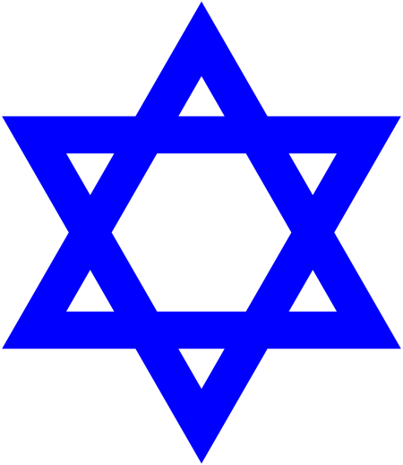
Judaism is one of the world's oldest monotheistic religions. It began somewhere around the year 2000 BC, when a man named Abraham moved from Mesopotamia to the other side of the Fertile Crescent, where the country of Israel is now located.

Abraham can be considered the founder of Judaism, because he stopped believing in many gods, like the other people in Mesopotamia. He started believing that there was just one god, who told him to make his big move.

People who follow Judaism are called Jews or Hebrews. The holy book of Judaism is called the Torah, which is actually a group of books. They are almost always grouped together. Jewish people gather each Friday night or Saturday morning in their holy place, which is called a synagogue (pronounced sin-a-gog). In the synagogue, Jewish people pray and read the Torah from a big scroll. They also usually listen to a speech from their teacher, who is called a rabbi (pronounced rab-eye).

Jewish people believe that Abraham's great-grandchildren were forced to move to Egypt, where their relatives became slaves of the Egyptians. A Jewish man named Moses was given the Ten Commandments by God, which are a set of laws. In the story, Moses led the Jewish people out of Egypt, and back to Israel.

Sources:
http://fmwr.blogspot.com/p/judaism.html

