Julius Caesar’s Epitaph
An Epitaph is a message on a tombstone that commemorates (remembers) the person buried there. You are going to create an epitaph for Julius Caesar. Using the following requirements.
- Full name of the deceased (dead)
- Date of birth and death
- 4 adjectives (Words that describe Caesar) You may not use the ones in the example!!!!
- 3 accomplishments (doesn’t need to be complete sentences)
- Tie up sentence or a quote (What Caesar Will be Remembered For?)
- Neatly written, try to center space (shown below)

Example:
Alexander the Great
356 B.C.-320 B.C.
courageous, dedicated, compassionate, and determined leader
expanded the Greek empire, built lighthouse at Alexandria, conquered Persia
Will be remembered by all as the greatest conqueror that ever lived.

Materials to use to research and gather information:
- Julius Caesar Mini-books (in class only)
- Textbook- p.286 and biographical dictionary
- Graphic organizer from class (Tuesday’s partner work)
- “Fall of Republic” questions (from Monday’s class)
- Internet sites: (use at home only)
http://rome.mrdonn.org/caesar.html
http://www.mrdowling.com/702-caesar.html
http://ancienthistory.about.com/cs/caesar1/a/caesartriumvir.htm
http://www.crystalinks.com/juliuscaesar.html

Elements | 0 | 1 | 2 | Total
Name | Missing name | Missing part of name or misspelled | Has full name spelled correctly | /2
Dates | Missing dates | 1 missing or incorrect date | Has correct birth and death dates | /2
Adjectives | Has 1-2 adjective | Has 3 adjectives | Has 4 adjectives | /2
Accomplishments | 1 accomplishment | 2 accomplishments | 3 accomplishments | /2
Tie Up | Missing | Tie up is not strong | Well written tie up | /2
Neatness | Very hard to read. | Difficult to read. | Very Neat | /2

TOTAL POINTS: ________________/12

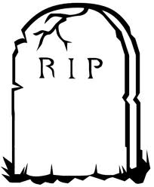

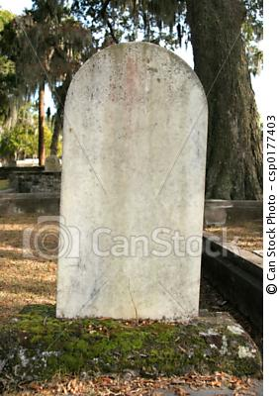 | 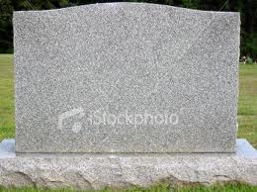
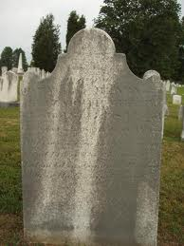 | 