Hanukkah = The Festival of Lights
On each night of Hanukkah, the menorah (MEN-or-ah) is lit. The menorah symbolizes the burning light in the temple, as well as marking the eight days of the Hanukkah festival. The menorah is used during the Jewish holiday of Hanukkah and honors the miracle of the oil.According to the Hanukkah story, once Jewish revolutionaries had retaken the Temple from the Syrians they wanted to rededicate it to God and restore its ritual purity. Eight days worth of oil were needed to complete the ritual ceremony, but they were only able to find one day's worth of oil. They lit the menorah anyway and amazingly the oil lasted for eight full days.

How to use the menorah
In celebration of this event Hanukkah is celebrated for eight days and a candle is lit on the hanukkiyah on each of those days. One candle is lit the first night, two the second, and so on, until the final night when all the candles are lit. Each of the eight candles is lit with a “helper” candle known as the shamash. The shamash is lit first, is used to light the other candles, and then is returned to the ninth candle spot, which is set apart from the others.It is customary to light the candles from left to right, with the newest candle being in the leftmost spot.It is forbidden to use the light of the hanukiyah for any other purpose – for instance, to light the dinner table or to read by.

Hanukkah begins at the 25th day of Kislev, the third month of the Jewish calendar. This year Hanukkah begins at sundown on the evening of December 5, 2013.
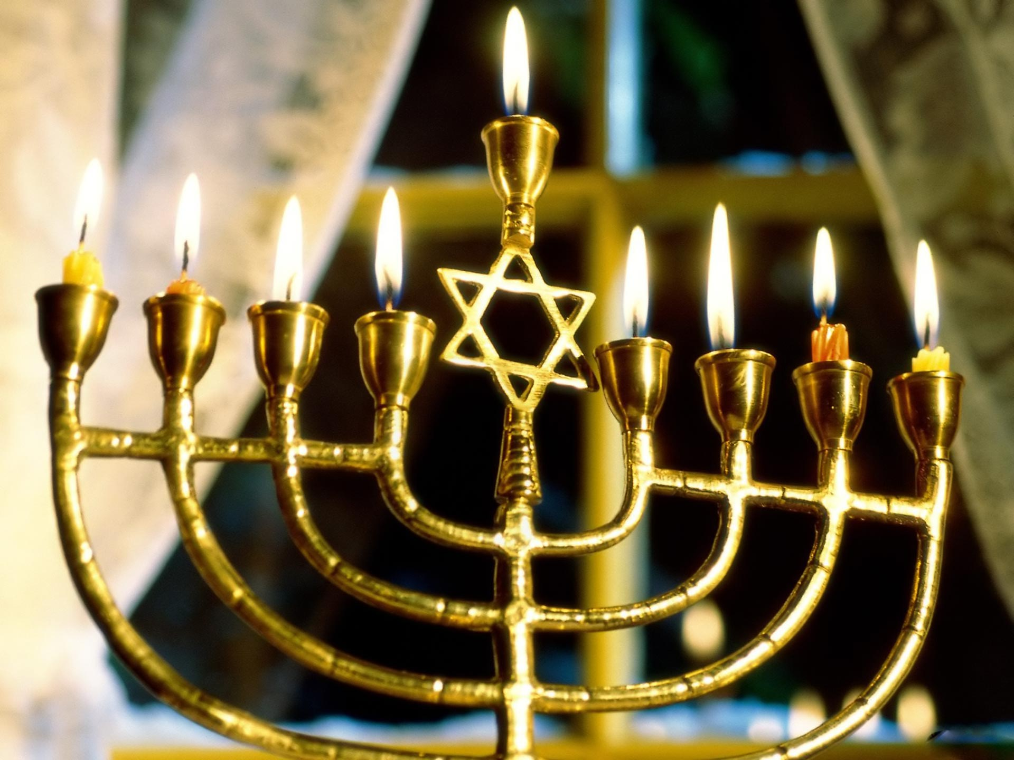

Passover
Passover was a Jewish spring festival that celebrated the first barley harvest after the winter. All winter there had not really been enough to eat, and then around March there was finally some fresh new barley bread to eat! People were in such a hurry to eat it that they couldn't wait for the bread to rise, and they ate flat bread called matzoh (math-saw). Jews decided that if Passover was so important, it must be the celebration of a very important event in Jewish history.
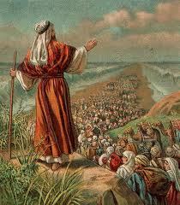
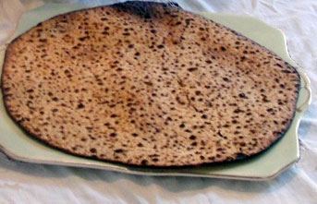

The beginning of the country of Israel - now that was a really important event! People would still eat matzoh, but they would also tell the story of Moses and how the Jews came to Israel. Passover tells the story of how Moses led the Jews out of Egypt to Israel,freedom and independence are something to celebrate.
According to the scriptures, Despite pharaoh's attempt to subdue the Hebrews through slavery they continue to have many children. As their numbers grow, pharaoh comes up with another plan: he will send soldiers to kill all newborn male babies who were born to Hebrew mothers. This is where the story of Moses begins.In order to save Moses, his mother and sister put him in a basket and set it afloat on the river. Their hope is that the basket will float to safety and whomever finds the baby will adopt him as their own. Eventually it is discovered by none other than pharaoh's daughter. She saves Moses and raises him as her own, so that a Hebrew child is raised as a prince of Egypt.
When Moses grows up he kills an Egyptian guard when he sees him beating a Hebrew slave. Then Moses flees for his life, heading into the desert. In the desert he joins the family of Jethro, and marriesJethro's daughter and having children with her. God tells Moses that he has been chosen to free the Hebrews from slavery in Egypt. Moses leads the Hebrews out of slavery in an event known as the Exodus.

Headcoverings or Kippah
Men cover their heads with a kippah(kee-pah) to shows their respect for God. Married religious women also often wear a head covering, such as a wig, scarf or hat. This shows their modesty.Kippah (pronounced kee-pah) is the Hebrew word for the skullcap traditionally worn by Jewish men. After the Star of David, they are probably one of the most recognizable symbols of Jewish identity.

Who Wears Kippah and When?
Traditionally only Jewish men wore kippah. However, in modern times some women also choose to wear kippah as an expression of their Jewish identity or as a form of religious expression.
When a kippah is worn varies from person to person. In Orthodox circles Jewish men usually wear kippah all the time, whether they are attending a religious service or going about their daily lives outside of the synagogue. In Conservative communities men almost always wear kippah during religious services or during formal occasions, such as during a High Holiday dinner or when attending a Bar Mitzvah.
Ultimately the decision about whether or not to wear a kippah comes down to personal choice and the customs of the community an individual belongs to. Religiously speaking, wearing kippah is not required and there are many Jewish men who do not wear them at all.
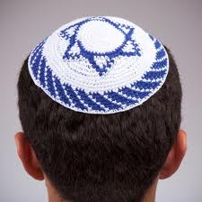
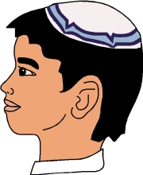

The Star of David

The six-pointed star known as the Star of Davidis an ancient symbol. In Judaism it is often called the Magen David, which means the "shield of David" in Hebrew. It is now the most common and universally recognized sign of Judaism and Jewish identity, both within and outside of the Jewish community.
The Star of David is a six-pointed star made up of two triangles placed over over each other. It doesn’t have any religious significance in Judaism but it is one of the symbols most commonly associated with the Jewish people. Many Jews wear jewelry with the Star of David as part of the design and the flag of Israel has a blue Star of David in the center. In many ways it has come to be a symbol of unity.

Symbolic Meanings
There are many ideas about the symbolic meaning of the Star of David. Some people think that the six points represented God's absolute rule over the universe in all six directions: north, south, east, west, up and down. They also believed that the triangles represented humanity’s dual nature – good and evil – and that the star could be used as protection against evil spirits.
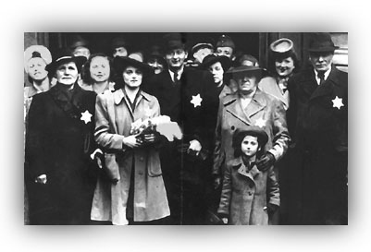

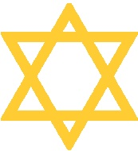

Tallit
The tallit (tah-leet) is known in English as a prayer shawl. It is worn during prayers and reminds us that God is protecting us and also symbolizes that we are wrapping God's laws around us. The tallit has been a symbol of Judaism for thousands of years. Most people have seen a tallit, even if they weren't sure what to call it. It is widely regarded within the Jewish community a great gift from God and a mitzvah to wear one while in prayer.
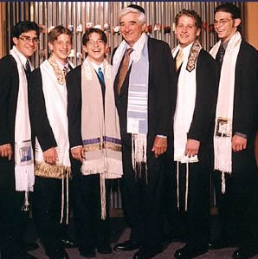
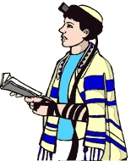

Yad
The word ‘yad’ means ‘hand’ in Hebrew. The yad is a decorative pointer in the shape of a hand that is used to show what place the reader is up to while reading the Torah. Jews use the yad while reading the Torah because it is believed the Torah is too sacred or holy to touch with your hand. A yad is a Jewish ritual pointer that is used to point to text during Torah reading that comes from the parchment Torah scrolls. The parchment is considered sacred hence a yad is used to prevent anyone from touching it. Silver is the material that is used to make it.
