Ancient Rome Vocabulary List
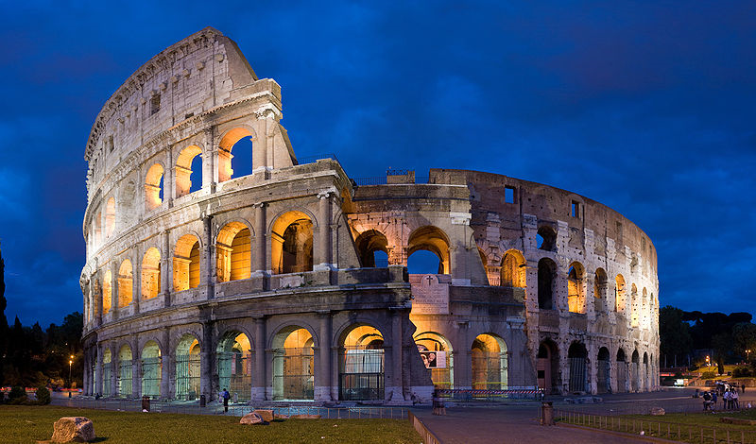

Rome Vocabulary Word | Definition of the Vocabulary Word | Rewrite the Definition in your own words! |  | Draw a Picture that Represents the Word.
Republic

Consuls

Dictator

Senate

Rome Vocabulary Word | Definition of the Vocabulary Word | Rewrite the Definition in your own words! |  | Draw a Picture that Represents the Word.
Plebeian

Patrician

Legion

Aqueduct

Forum

